Hosting a website on AWS EC2 Instance with Auto Scaling group, Application Load Balancer and Web Application Firewall (WAF) and Monitor with Cloud Watch and Add Simple Notification Service (SNS) for it.
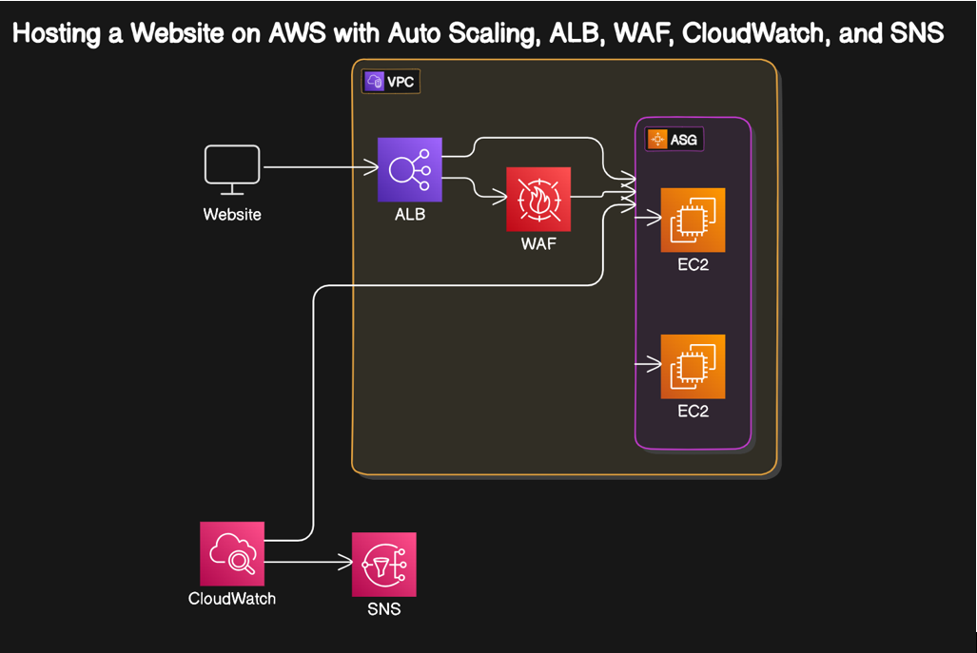

Steps:
- Create launch template (name: mytemp-1; OS: Ubuntu 22.04; Instance type: t2.micro; Subnet: Don’t include in launch template; Security Group: Existing one – default; Storage: 8Gib; Advanced details – User data, paste the below content) – Create launch template

We are adding web server (apache2), download the website code file in it & unzip the code file.

#! /bin/bash
sudo apt update -y
sudo apt install apache2 -y
sudo apt install unzip -y
sudo wget https://www.free-css.com/assets/files/free-css-templates/download/page296/oxer.zip
sudo unzip oxer.zip
sudo mv oxer-html/ * /var/www/html
sudo systemctl restart apache2
sudo systemctl enable apache2

- Now, let us create auto scaling group from launch template (name: web-auto-1; launch template: mytemp-1; Availability Zones & Subnets: Choose a & b for high availability reason; load balancing: attach to a new load balancer; load balancer type: application load balancer; load balancer scheme: Internet-facing; under listeners and routing – default routing: create a target group; Group size: Desired capacity (1), Min desired capacity (1), Max desired capacity (4); Add notification – Send a notification to (my_topic); recipients (akshivrajendran2011@gmail.com); Create auto scaling group.
[Make sure you are opening load balancer, target group, sns, subscriptions, auto scaling, launch templates everything on separate tabs]
[Do verify the subscription from the email manually]

- Add Web Application Firewall (WAF), Select IP Sets, (name: ip_rule; Region: make sure we are in the right region (Ohio); IP addresses: 103.162.158.172/31) – Create IP set.

- Next, let us create web ACL (name: ACL-1; add AWS resources, choose Application load balancer, select the ALB (web-auto-1-1), add; next – add rule type (my own rules and rule groups); choose the IP set; name: rule-1; select the IP set (ip_rule); next, select the rule priority (rule-1); next, set rule priority (rule-1) next; next, create web ACL

